
EDGE CAPSTONE PROJECT · OPTION B: PREDICTIVE MODELLING
Predicting Customer Churn
A Logistic Regression Approach to Subscription Retention
Dataset: Kaggle Customer Churn Dataset — 64,374 customers, 11 predictors
Software: R (glm, car, ROCR) | Method: Binary Logistic Regression

Presented by Team No 4
Arppit Sharma — iimsi_edge_2511092
Poli Vardhini Reddy — iimsi_edge_2511063
Tulika Saha — iimsi_edge_2511105
Rajay Paliwal — iimsi_edge_2511191
Tirth Makwana — iimsi_edge_2511048
Rahul Tandon — iimsi_edge_2511168
Date: 1/8/2026
Table of Contents

Contents | Page no.
Executive Summary | 3
(1)The Business Problem | 4
Objectives | 5
(2) Methodology | 6
(2.1) Dataset Overview | 6
(2.2) Analytical Workflow | 6
(2.3) Building the Model | 7
(2.4) Tools | 9
(2.5) Why Customer ID was excluded | 9
(3) Interpretation of Results | 10
(3.1) Model Coefficients and Odds Ratios | 10
(3.2) Overall Model Fit | 12
(3.3) Choosing the Classification Threshold | 12
(3.4) Predictive Performance on unseen data | 12
(3.5) Independent Validation using Orange Data Mining | 14
(4) Solutions and Recommendations | 16
(4.1) Turning Scores into Actions: Risk Tiers | 16
(4.2) Four Priority Actions | 16
(4.3) Using Gender Responsibly | 17
(4.4) Estimating Business Impact | 17
(4.5) Validating and Sustaining the Model after Deployment | 18
(4.6) Directions for Improvement | 18
(5) Limitations | 19
(6) Conclusion | 20
(7) References | 21

Executive Summary
Customer churn is one of the most significant challenges faced by subscription-based businesses because losing existing customers directly reduces long-term revenue and increases customer acquisition costs. The objective of this capstone project was to develop a predictive model capable of identifying customers who are likely to discontinue their subscription before they actually churn.
This study used the publicly available Customer Churn Dataset from Kaggle, containing 64,374 customer records with demographic, behavioural, contractual, and financial attributes. Data preprocessing included encoding categorical variables, correlation analysis, train-test splitting, and variable selection through forward logistic regression modelling. Model performance was evaluated using Residual Deviance, Akaike Information Criterion (AIC), Variance Inflation Factor (VIF), confusion matrix, ROC curve, and classification metrics. CustomerID was deliberately excluded from the final model because, despite improving statistical fit, it is an identifier rather than a meaningful business predictor.
The final Logistic Regression model achieved 82.0% prediction accuracy on unseen test data, with 84.0% precision, 76.6% recall, and a McFadden Pseudo R² of 0.43, indicating good predictive performance. Independent validation using Orange Data Mining produced comparable results, further confirming the robustness of the model.
The analysis identified Payment Delay, Support Calls, Contract Length, Usage Frequency, Total Spend, and Subscription Type as important factors influencing customer churn. Based on these findings, practical business recommendations were proposed, including proactive payment reminders, prioritised customer support, improved customer engagement, and targeted retention campaigns. Overall, the project demonstrates how Logistic Regression can effectively transform historical customer data into actionable insights that support data-driven customer retention strategies.

1. The Business Problem
Subscription businesses depend on recurring revenue, which means retention is not a secondary concern but the foundation of the business model itself. Every customer who cancels represents not just a single lost transaction but the loss of an entire future stream of revenue. Because acquiring a new customer is generally understood to cost substantially more than retaining an existing one, a high churn rate does not merely dent short-term sales — it compounds into a structural drain on profitability over time.
This capstone project examines the Kaggle Customer Churn dataset, comprising 64,374 customer records and 11 behavioural, demographic, and contractual predictors, with no missing values. Within this dataset, 47.4% of customers (30,493 of 64,374) have already churned — essentially one in every two customers. A churn rate at this level, if representative of the business, would represent a substantial and recurring loss of revenue; translating it into an exact currency figure would require the company's own cost and revenue data, which this dataset does not contain, so this report deliberately avoids presenting a specific monetary loss estimate (see Section 5, Limitations).
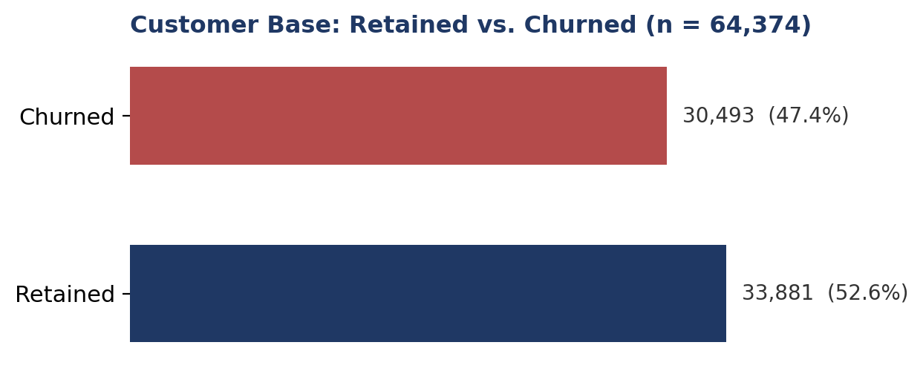
A churn rate at this level cannot be addressed through blanket, reactive measures — broad discounts or generic win-back campaigns are expensive and inefficient because they cannot distinguish between customers who are genuinely at risk and those who were never going to leave. The business needs a way to identify which customers are likely to churn, understand why they are likely to churn, and act before they do.

Objectives
- Identify the key behavioural, demographic, and contractual drivers that make a customer likely to churn.
- Build a statistically sound, interpretable model that flags at-risk customers before they leave.
- Translate the findings into targeted, cost-effective retention actions that the business can implement.
Every subsequent section of this report — the methodology, the results, and the recommendations — is built to serve these three objectives in sequence: understand the problem, build a model that predicts it, and convert that prediction into action.

2. Methodology

2.1 Dataset Overview
Table 1 summarises the dataset before any modelling was carried out.
Attribute | Value
Records | 64,374 customers, 12 columns (Customer ID, 10 predictors, Churn), no missing values
Churn rate | 47.4% churned (30,493) · 52.6% retained (33,881)
Gender | Female 34,353 (53.4%) · Male 30,021 (46.6%)
Subscription Type | Standard 21,502 · Basic 21,451 · Premium 21,421 (roughly even thirds)
Contract Length | Monthly 22,130 · Annual 21,410 · Quarterly 20,834 (roughly even thirds)
Age / Tenure | Age range 18–65 (mean ≈ 42); Tenure measured in months with the company
Payment Delay / Support Calls | Mean ≈ 17.1 days late / mean ≈ 5.4 calls
Total Spend | Mean ≈ 541 (currency units as provided in the dataset)

2.2 Analytical Workflow
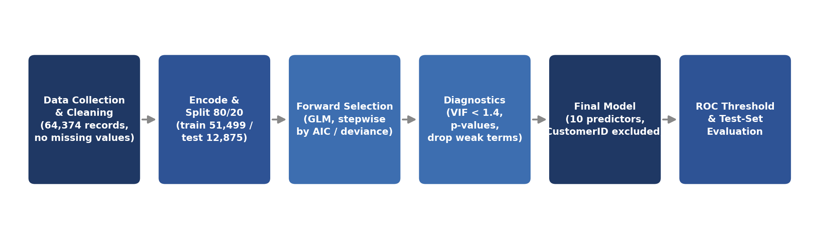
The dependent variable, Churn, is binary: 1 indicates the customer left, 0 indicates the customer stayed. Because the outcome is categorical rather than continuous, logistic regression — not linear regression — is the statistically appropriate tool. Linear regression assumes a continuous, unbounded outcome and can produce fitted probabilities below 0 or above 1, which have no meaningful interpretation for a yes/no outcome. Logistic regression instead models the log-odds of churn and constrains predicted probabilities to the valid 0–1 range.
Eleven independent variables were considered, grouped into three categories:
- Behavioural: Support Calls, Payment Delay, Usage Frequency, Total Spend, Tenure, Last Interaction
- Demographic: Age, Gender
- Contract: Subscription Type (Basic / Standard / Premium), Contract Length (Monthly / Quarterly / Annual)
Categorical fields were one-hot encoded ahead of modelling. As an initial diagnostic, each numeric variable's correlation with churn was calculated to guide which predictors were most likely to matter. Payment Delay (r = 0.557) and Support Calls (r = 0.305) showed the strongest positive association with churn, while Usage Frequency (r = −0.115) and Gender coded as Male (r = −0.165) showed the strongest negative association. CustomerID also showed a notably high correlation with churn (r = 0.530); this is addressed directly in Section 2.5, since it is not a behavioural signal. These correlations were a starting diagnostic, not the final word — the regression model itself formally tested each variable's contribution while controlling for the others.

2.3 Building the Model
The modelling process followed four disciplined steps:
- Split the data: 80% training (51,499 records) and 20% test (12,875 records), with a fixed random seed for reproducibility.
- Forward selection: variables were added one at a time, and each was retained only if it produced a genuine improvement in model fit.
- Check each step: Akaike Information Criterion (AIC) and residual deviance were tracked at every step, and Variance Inflation Factor (VIF) was checked to rule out multicollinearity among predictors.
- Drop weak predictors: variables that were statistically insignificant or that increased AIC were removed.
The chart and table below trace how model fit improved as variables were added, using the model that excludes Customer ID throughout. Residual deviance — a measure of unexplained variation, where lower is better — fell from a null-model baseline of 71,250 to a final value of 40,342 across ten steps.
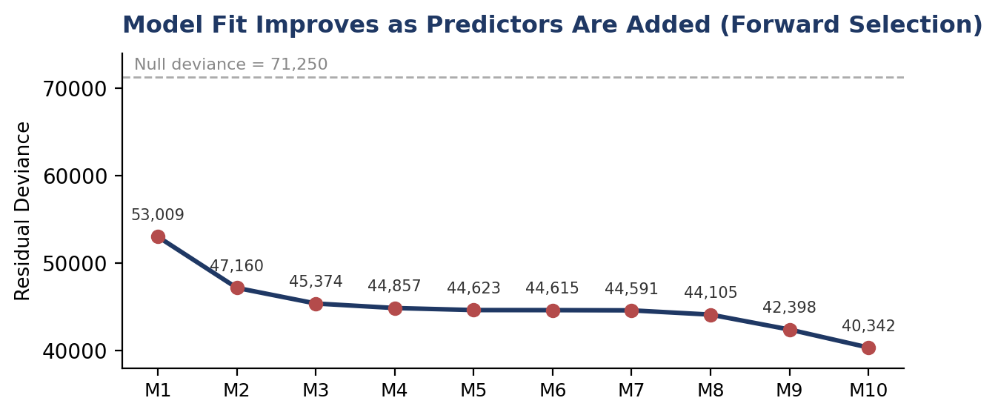
Step | Variable added | Residual Deviance | AIC
M1 | Payment Delay | 53,009 | 53,013
M2 | Support Calls | 47,160 | 47,166
M3 | Tenure | 45,374 | 45,382
M4 | Age | 44,857 | 44,867
M5 | Contract Length = Monthly | 44,623 | 44,635
M6 | Subscription Type = Basic | 44,615 | 44,629
M7 | Contract Length = Annual | 44,591 | 44,607
M8 | Total Spend | 44,105 | 44,123
M9 | Usage Frequency | 42,398 | 42,418
M10 (final) | Gender | 40,342 | 40,364
Table 3 lists every variable that was considered and then dropped, with the specific reason for removal rather than a general label of “insignificant”:
Variable considered | Reason removed
Last Interaction | Not statistically significant; inclusion raised AIC rather than lowering it
Subscription Type = Standard | Not statistically significant; raised AIC
Subscription Type = Premium | Not statistically significant; raised AIC, and reduced the significance of Subscription Type = Basic through overlap
Contract Length = Quarterly | Retained as the reference category for the Contract Length dummies (not removed for insignificance) — needed to avoid the dummy-variable trap
Customer ID | A record identifier, not a behavioural feature; excluded on principle even though including it lowers residual deviance to 32,255 and AIC to 32,279 (see Section 2.5)
Contract Length (Quarterly) was deliberately held out as the reference category for the Contract Length dummy variables, to avoid the dummy-variable trap that would otherwise make the model matrix singular; it was not dropped for lack of significance.
Multicollinearity was checked using VIF at every step, and all ten retained predictors in the final model returned values below 1.4 (the highest being Contract Length = Annual at 1.36) — well under the conventional concern threshold of 5 — confirming that no two predictors are redundant with one another. The final model’s AIC is 40,364, down from 53,013 at the first step of forward selection.

2.4 Tools
All modelling was carried out in R, using the glm() function for logistic regression, the car package for VIF diagnostics, and the ROCR package for ROC-curve analysis and threshold selection.

2.5 Why Customer ID Was Excluded
During model development, Customer ID was tested as a predictor out of methodological curiosity. Adding it lowers residual deviance sharply, from 40,342 to 32,255, and AIC from 40,364 to 32,279 — a larger single improvement than any genuine behavioural variable produced. This is a red flag rather than a genuine finding: Customer ID is a record identifier assigned when a customer’s row was created, and there is no plausible mechanism by which an ID number could cause a customer to churn. Its apparent predictive power most likely reflects an artifact of how the dataset was generated or ordered (for example, if records were appended in batches that happen to correlate with churn status) rather than a real behavioural relationship. Including it would inflate the model’s apparent performance while adding a variable the business could never act on. For this reason, Customer ID is excluded from the final model, and every coefficient, fit statistic, and confusion-matrix figure reported in Section 3 comes from the model that omits it.

3. Interpretation of Results

3.1 Model Coefficients and Odds Ratios
The final model (Model 10) retains ten predictor terms, all significant at p < 0.01 and all but one at p < 0.001 (Subscription Type = Basic is significant at p = 0.002). Categorical effects are shown relative to their reference category: Contract Length is relative to Quarterly, and Subscription Type is relative to Premium/Standard. Odds ratios are the most intuitive way to read these results: a ratio above 1 means the factor raises the odds of churn, and a ratio below 1 means it lowers the odds of churn.
Predictor | β (coefficient) | Odds Ratio | Effect | p-value
Payment Delay | +0.214 | 1.24 | ↑ Increases churn | < 0.001
Support Calls | +0.334 | 1.40 | ↑ Increases churn | < 0.001
Contract = Monthly | +0.484 | 1.62 | ↑ Increases churn | < 0.001
Contract = Annual | +0.156 | 1.17 | ↑ Increases churn | < 0.001
Tenure | +0.035 | 1.04 | ↑ Increases churn | < 0.001
Age | +0.020 | 1.02 | ↑ Increases churn | < 0.001
Subscription = Basic | +0.081 | 1.08 | ↑ Increases churn | 0.002
Usage Frequency | −0.061 | 0.94 | ↓ Decreases churn | < 0.001
Total Spend | −0.001 | 0.999 | ↓ Decreases churn | < 0.001
Gender = Male | −1.141 | 0.32 | ↓ Decreases churn | < 0.001
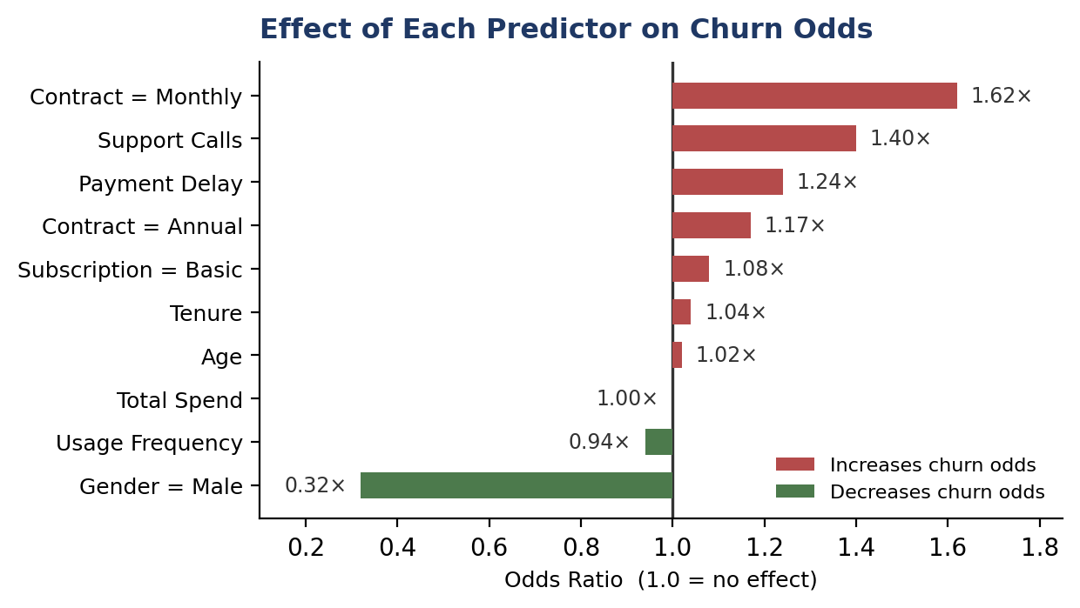
Reading these results together tells a coherent, largely behavioural story. Payment Delay is the strongest actionable driver: each additional day of payment delay raises the odds of churn by about 24%. Support Calls are nearly as important: each additional call raises churn odds by about 40%, a clear signal of accumulating service frustration. Monthly-contract customers churn at roughly 62% higher odds than quarterly-contract customers (the reference category), and annual-contract customers show a smaller but still significant 17% higher odds than quarterly — an unexpected pattern worth further investigation, though it may reflect the specific customer segments each contract length attracts in this dataset rather than the length of the commitment itself.
Two findings are less intuitive and worth flagging for further investigation rather than immediate action. First, Tenure carries a positive coefficient — longer-tenured customers churn slightly more, not less, in this dataset (odds ratio 1.04 per unit of tenure). A plausible explanation is renewal fatigue or complacency around contract renewal points, though this is a pattern observed in the data rather than a proven cause, and it suggests loyal customers should not be assumed to be safe from churn. Second, Gender shows a substantial effect: male customers have far lower odds of churning than female customers (odds ratio 0.32). This is a demographic pattern in the data, not a licence to target customers differently by gender — the appropriate response is to investigate the underlying behavioural or service causes of the gap, discussed further in Section 4.2.
On the protective side, higher Usage Frequency and higher Total Spend both lower the odds of churn, consistent with the intuitive idea that engaged, higher-value customers are less likely to leave.
In plain business terms: customers who fall behind on payments are financially disengaging from the relationship before they leave it; customers who call support repeatedly are signalling unresolved dissatisfaction; and customers who spend more and use the product more often are demonstrating loyalty through behaviour, not just stated intent. These three ideas — payment friction, service frustration, and engagement — are the throughline connecting the statistics to the recommendations in Section 4.

3.2 Overall Model Fit
Three summary statistics describe how well the model fits the data as a whole:
- McFadden Pseudo R² = 0.43 (1 − 40,342 / 71,250) — a solid value for behavioural data of this kind, where R² values are typically much lower than in physical-science contexts.
- Likelihood-ratio χ² = 30,908 (71,250 − 40,342) on 10 degrees of freedom, p < 0.001 — confirming that the model as a whole is highly statistically significant.
- AIC = 40,364 for the final model, down from 53,013 at the first step of forward selection.

3.3 Choosing the Classification Threshold
A logistic regression outputs a probability, not a yes/no decision, so a cutoff has to be chosen to convert that probability into a "predicted churn" flag. The ROC (Receiver Operating Characteristic) curve was plotted for the final model with candidate cutoffs marked at 0.2 intervals from 0.2 to 0.9, plotting the true-positive rate against the false-positive rate at each threshold.
A threshold of 0.60 was selected rather than the conventional default of 0.50. At 0.50, the model classifies more customers as at-risk, which raises recall (catching more true churners) but also raises the false-positive rate, flagging more loyal customers as at-risk than necessary and diluting retention spend. Moving the cutoff to 0.60 trades a modest amount of recall for a meaningful gain in precision: fewer flagged customers turn out to be false alarms, which matters directly for a business deciding who receives a retention offer. This is a deliberate choice grounded in the ROC curve and the cost asymmetry between a wasted retention offer (a false positive) and a missed churner (a false negative), not an arbitrary or default value.

3.4 Predictive Performance on Unseen Data
A model that fits the training data well is not automatically useful — it also has to generalise to new customers it has never seen. The final model was evaluated on the 12,875-customer held-out test set at the chosen 0.60 cutoff.
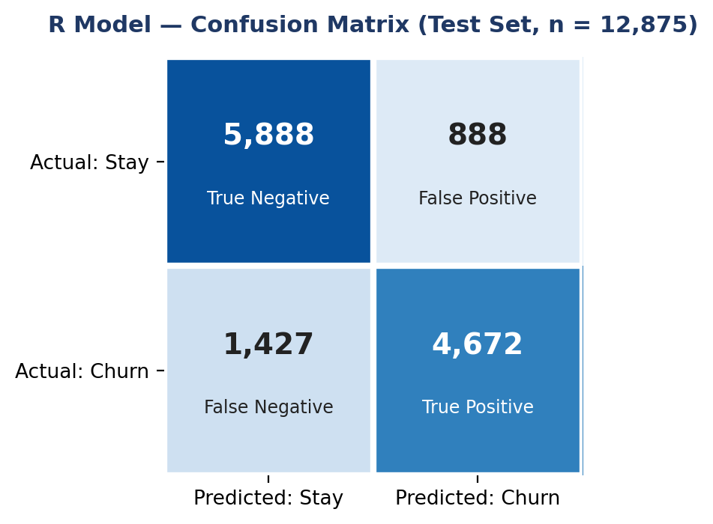
 |  | Predicted: Stay |  | Predicted: Churn
Actual: Stay |  | 5,888 (True Negative) |  | 888 (False Positive)
Actual: Churn |  | 1,427 (False Negative) |  | 4,672 (True Positive)
Metric | Value |  | Interpretation
Accuracy | 82.0% |  | Share of all predictions (stay/churn) correct on unseen test data
Precision | 84.0% |  | Of customers flagged as churn risks, 84.0% actually churned — retention spend is not wasted
Recall (Sensitivity) | 76.6% |  | The model catches 76.6% (4,672 of 6,099) of customers who genuinely churn
F1-Score | 80.1% |  | Harmonic mean of precision and recall — balances false alarms against missed churners
In practical terms, the model correctly identified 4,672 of the 6,099 customers who actually churned in the test set — catching just over three out of every four real churners — while correctly clearing 5,888 loyal customers. When the model does flag a customer as a churn risk, it is right 84.0% of the time, meaning retention spend directed at flagged customers is rarely wasted on someone who was never going to leave. Together, an 82.0% accuracy rate, an 84.0% precision rate, and a 76.6% recall rate represent numbers a business can act on with reasonable confidence, while recognising — per Section 3.3 — that a different threshold would trade some precision for additional recall if the business preferred to catch more churners at the cost of more false alarms.

3.5 Independent Validation Using Orange Data Mining
As a robustness check, the same ten predictors (CustomerID excluded, consistent with Section 2.5) were used to rebuild the model independently in Orange Data Mining, an alternative tool with its own logistic-regression implementation. Rather than a single 80/20 holdout split, Orange evaluated the model using 10-fold stratified cross-validation across the full 64,374-customer dataset, giving a second, methodologically distinct read on model quality.
Metric | Value | Interpretation
AUC | 0.904 | Excellent ability to separate churners from non-churners across all thresholds
Accuracy (CA) | 82.7% | Correctly classified roughly 83 of every 100 customers
Precision | 82.7% | Consistent with recall — the model does not favour one class over the other
Recall | 82.7% | Consistent with precision — a balanced, non-skewed classifier
F1-Score | 0.826 | Balanced harmonic mean of precision and recall
MCC | 0.652 | Strong agreement between predictions and actual outcomes (0 = random guessing, 1 = perfect)
Orange also reports two metrics not produced by the R pipeline: AUC (Area Under the ROC Curve), which summarises separation between churners and non-churners across every possible threshold rather than just one, and MCC (Matthews Correlation Coefficient), a single balanced measure that accounts for all four confusion-matrix quadrants at once and is considered more robust than accuracy alone. An AUC of 0.904 and an MCC of 0.652 both indicate a genuinely strong classifier rather than one that merely benefits from the roughly even class split in this dataset.
 | Predicted: Retained | Predicted: Churned
Actual: Retained | 27,965 (True Negative) | 5,916 (False Positive)
Actual: Churned | 5,268 (False Negative) | 25,225 (True Positive)
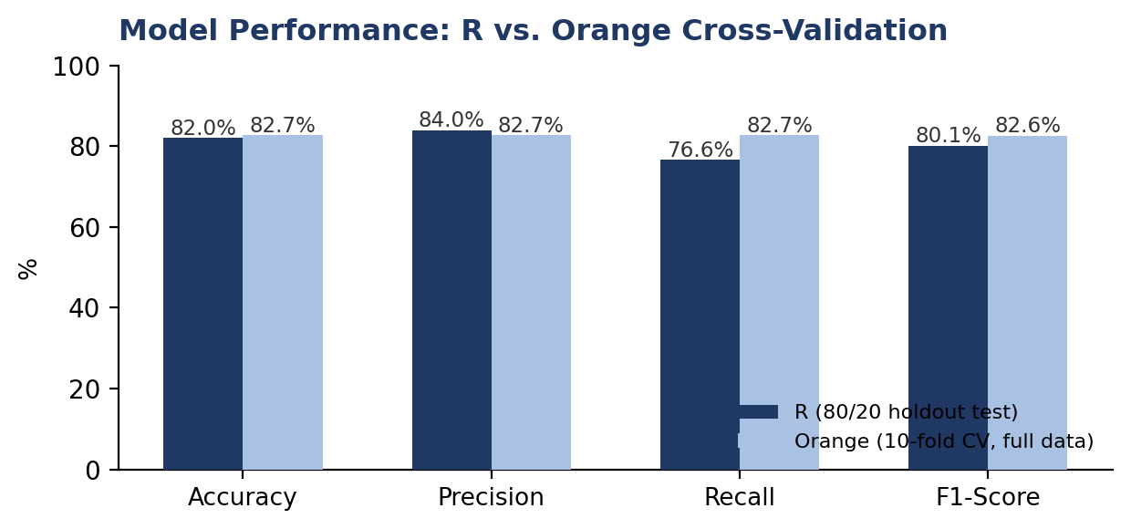
Read across the full dataset, this confusion matrix tells the same story as the R holdout test in Section 3.4 at a larger scale: 25,225 of 30,493 actual churners were correctly caught (an 82.7% recall, close to the 76.6% seen on the smaller held-out test set), and the large majority of loyal customers were correctly left alone. The two pipelines used different tools, different validation schemes, and slightly different coefficient magnitudes — Orange's logistic regression applies L1/L2 regularisation by default, which shrinks coefficients toward zero relative to R's unregularised estimates — yet both agree on which variables matter, the direction of their effect, and an overall accuracy in the low-to-mid 80% range. That agreement across two independent implementations is a meaningful check that the result is a genuine pattern in the data rather than an artifact of one tool or one train/test split.

4. Solutions and Recommendations
The purpose of a churn model is not simply to explain the past but to change what the business does next. Each recommendation below is tied directly to a statistically significant driver identified in Section 3, so that retention spend is directed at the levers that actually move churn rather than spread thinly across the customer base.

4.1 Turning Scores into Action: Risk Tiers
Rather than reviewing 64,374 individual probabilities by hand, the model's output can be operationalised into three simple tiers that route customers to the right level of attention automatically:
Risk Tier | Predicted Churn Probability | Recommended Action
Urgent | ≥ 0.80 | Immediate, high-priority outreach: account-manager call, payment grace period, or a steep renewal incentive
Watchlist | 0.50 – 0.79 | Lighter-touch retention: automated check-in emails, feature tutorials, or a modest loyalty offer
Safe Zone | < 0.50 | No intervention: continue standard billing and communications, preserving retention budget

4.2 Four Priority Actions
1. Fix billing friction. Payment Delay is the single strongest driver of churn (odds ratio 1.24 per additional day late). Proactive payment reminders, easy auto-pay enrolment, and flexible due dates directly target the largest lever available to the business.
2. Rescue frustrated callers. Each additional support call raises churn odds by roughly 40% (odds ratio 1.40). Customers with three or more support calls should be automatically flagged for priority resolution and a follow-up from a dedicated retention specialist, before frustration converts into cancellation.
3. Drive product engagement. Low usage frequency is associated with higher churn (odds ratio 0.94 per additional use, i.e. more usage is protective). Structured onboarding, usage nudges, and in-product education for light users can measurably lower churn.
4. Lock in longer contracts and reward loyalty. Monthly-plan customers churn at roughly 62% higher odds than quarterly customers, so incentivising quarterly commitments — and rewarding Basic-tier customers who upgrade or renew — reduces the pool of customers who can leave at short notice. Because tenure itself carries a positive churn relationship, this should be paired with proactive check-ins for long-standing customers rather than an assumption that loyal customers require no attention.

4.3 Using Gender Responsibly
Gender is a statistically significant predictor in the model, with female customers showing substantially higher churn odds than male customers. This pattern should be used only as a prompt for further investigation into its underlying behavioural or service-experience causes — for example, whether certain product features, pricing tiers, or service touchpoints affect one group disproportionately — and not as a basis for offering different treatment, pricing, or service levels by gender. The ethical and defensible use of this finding is to diagnose root causes, not to target directly on a demographic attribute.

4.4 Estimating Business Impact
Because this analysis is built on a public Kaggle dataset rather than the company's own financial records, this report does not attach a specific currency figure to the value of the retention programme — doing so would imply a precision the underlying data cannot support. What can be said with confidence is directional: the model's precision (84.0%) means a retention budget directed at flagged customers is spent efficiently rather than scattered broadly, and its recall (76.6%) means the majority of at-risk customers are identified while there is still time to intervene. The concrete rupee or dollar value of the programme — cost per retention offer, win-back rate, and average customer revenue — should be estimated using the company's own figures once available, and validated empirically rather than assumed (see Section 4.5).

4.5 Validating and Sustaining the Model After Deployment
- Validate impact with a pilot or A/B test: compare retention and revenue outcomes for a group of customers targeted using model scores against a control group, using the company's own cost and revenue data, before scaling the programme.
- Monitor for drift: customer behaviour and market conditions change over time, so the model should be retrained periodically rather than treated as a one-time deliverable.
- Recalibrate if performance degrades: if accuracy or recall drops after deployment, retrain on more recent data and reassess the probability threshold rather than continuing to apply a stale cutoff.
- Track KPIs monthly: churn rate, retention rate, model recall, retention-campaign ROI (once measurable), and customer lifetime value (CLV).

4.6 Directions for Improvement
Several extensions could sharpen the model further: satisfaction/NPS data, usage-trend features rather than a single snapshot, text-mined complaint categories, and interaction effects (e.g., whether payment delay's effect differs by contract type). More flexible approaches such as tree ensembles or deep learning could capture non-linear relationships the logistic model misses, at the cost of interpretability — a trade-off that matters for a business audience that needs to act on why a customer is at risk, not just that they are.

5. Limitations
- Data source and scope: this analysis uses a public Kaggle dataset rather than the company's own transactional and financial records, so factors such as competitor pricing, macroeconomic conditions, customer-satisfaction scores, and service outages are not observed and cannot be modelled. The unusually high 47.4% churn rate is also markedly higher than is typical for real subscription businesses, which may limit how directly the findings generalise.
- Correlation, not causation, and the CustomerID anomaly: relationships such as the positive association between tenure and churn, or between gender and churn, describe patterns in the data rather than proven causal mechanisms. CustomerID's strong statistical relationship with churn (Section 2.5) is almost certainly a data artifact, illustrating why statistical significance alone is not sufficient justification for including a variable.
- Threshold and cost assumptions: the 0.60 classification threshold balances precision and recall using the ROC curve, but the "right" threshold ultimately depends on the relative business cost of a false alarm versus a missed churner, which was not available for this analysis.
- No time dimension: the dataset is a single snapshot rather than a longitudinal record, so the model cannot currently distinguish a customer who is newly at risk from one whose risk has been stable for some time, which matters for prioritising outreach.

6. Conclusion
Three conclusions follow from this analysis. First, the model works: 82.0% accuracy and a McFadden Pseudo R² of 0.43 on a held-out test set, using only genuine behavioural, demographic, and contractual predictors, are reliable enough to base real decisions on. Second, churn in this dataset is behavioural rather than fundamentally demographic — payment delays, support-call volume, and low usage are the strongest and, importantly, the most fixable drivers, meaning the business has direct levers it can pull. Third, because the model produces an individual churn probability for every customer, retention spend can be targeted precisely at the customers most likely to leave rather than spread evenly, or worse, reactively, across the base.
Put simply, predicting churn turns retention from guesswork into a targeted, measurable strategy. The recommendations in Section 4 — fixing billing friction, resolving support frustration quickly, driving engagement among light users, and rewarding longer commitments and loyalty — translate the statistical findings directly into a practical retention programme, with a clear path to validate and sustain its impact after deployment using the business's own data.

7. References
- Azeem, M. S. (2024). Customer Churn Dataset. Kaggle. https://www.kaggle.com/datasets/muhammadshahidazeem/customer-churn-dataset
- Hosmer, D. W., Lemeshow, S., & Sturdivant, R. X. (2013). Applied Logistic Regression (3rd ed.). Wiley.
- James, G., Witten, D., Hastie, T., & Tibshirani, R. (2021). An Introduction to Statistical Learning (2nd ed.). Springer.
- R Core Team. (2025). R: A Language and Environment for Statistical Computing. R Foundation for Statistical Computing.
- Fox, J., & Weisberg, S. car: Companion to Applied Regression (R package documentation).
- Sing, T., et al. ROCR: Visualizing Classifier Performance in R.
- Demšar, J., et al. (2013). Orange: Data Mining Toolbox in Python. Journal of Machine Learning Research.

